Inveon GATE Model Mapping

This document describes mapping of critical parameters of the Inveon Preclinical Imaging System to GATE model functions within the individual macro files. If possible, all configuration with regard to the interface should be user configurable. For example, if the current version of the GUI support selection of the 4 collimator types, it should be made easy to add additional collimators such as using configuration files for the GUI to enable such customization.

1. SPECT

Acquisition Setup Screenshot

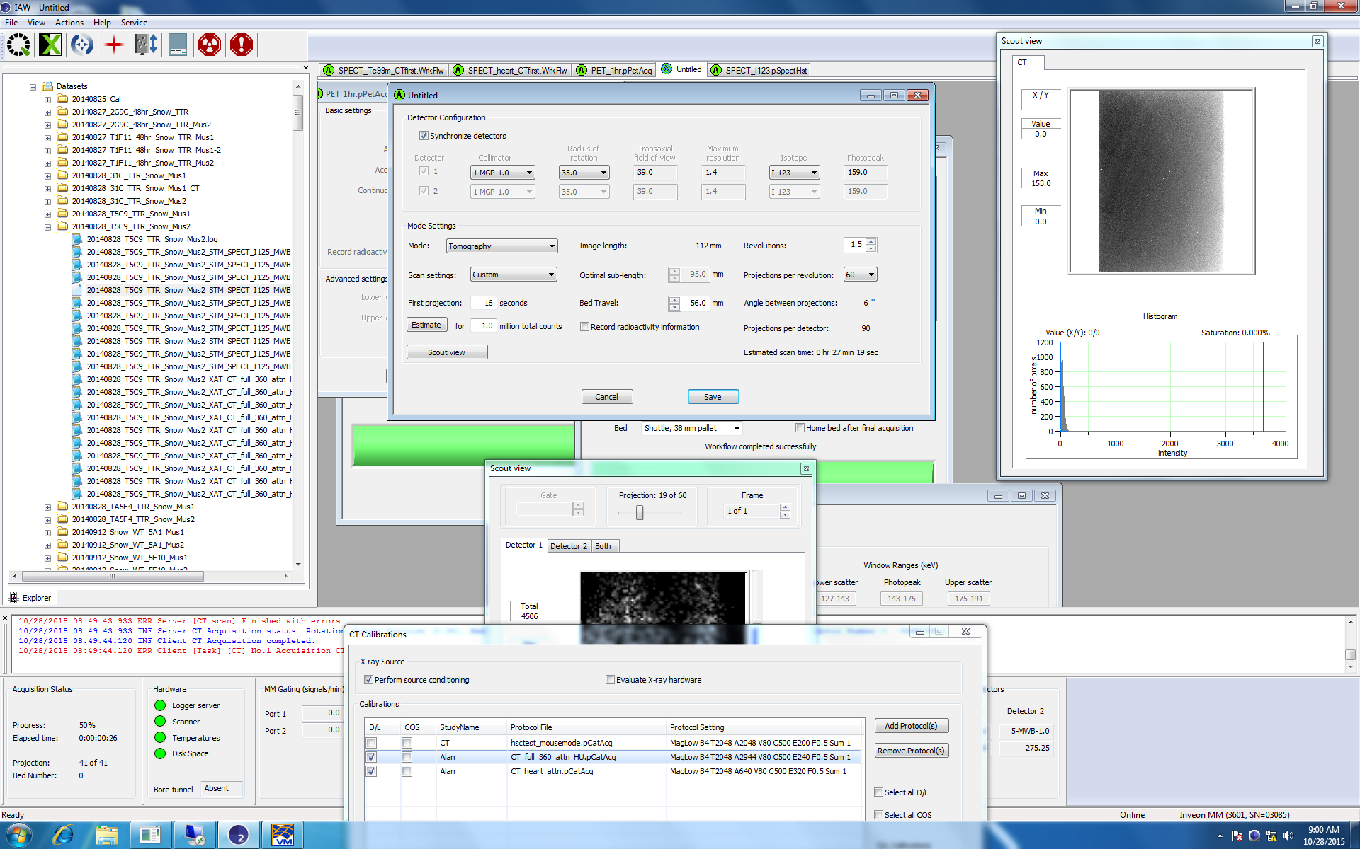

Key Parameters

* **Collimator type:** Selects the desired collimator Type – 4 modeled but more could be added– selected as part of acquisition simulation .mac file
  + 1-MGP-1.0:
    - configured by 1MGP10.mac
  + 5-MWB-1.0:
    - configured in 5MWB.mac
  + 1-MHR-0.5:
    - Configured in 1MHR05.mac
  + 1-MME-3.0:
    - Configured in 1MME30.mac
  + This should also automatically choose the appropriate *inveonhousing.mac file.
  + **Expected usage**: When the user selected the appropriate collimator, the simulation .mac file will automatically populate the appropriate command switch to select the collimator in the Collimator section of the .mac file. For example, selection of the 1-MGP-1.0 collimator will result in the following command line entered under the #Collimator section:

/control/execute 1MGP10.mac

As well as addition of the following line under the #SPECTheadhousing section:

/control/execute 1MGP10_inveonhousing.mac

* **Radius of rotation:** Selects the distance from the object being scanned to the face of the detector
  + 3 are modeled but more could be added
  + Selected in main simulation.mac file
  + **Expected usage**: User should be able to choose: 25, 30, or 35, or 360 mm with the following respective command lines
    - /gate/SPECThead/placement/setTranslation 122.5 0. 0. mm
    - /gate/SPECThead/placement/setTranslation 127.5 0. 0. Mm
    - /gate/SPECThead/placement/setTranslation 127.5 0. 0. Mm
    - /gate/SPECThead/placement/setTranslation 457.5 0. 0. Mm
* **Isotope:** selects the radioactive source used in the phantom or object. 4 primary isotopes have been modeled with corresponding digitizers.
  + Isotope selection used to choose appropriate simulation digitizer
  + **Expected usage**: User should be able to choose the isotope used for the scan which will create the appropriate command for digitizer selection.
  + Under #Digitizer simulation .mac file heading the following command should be issued:
  + /control/execute ../mac/digitizer.mac
    - Where digitizer.mac can be one of the following:
      * COBALT57_digitizer.mac
      * I123_digitizer_HI.mac
      * I123_digitizer_LO.mac
      * I125_digitizer.mac
      * T99M_digitizersp20.mac
* **Number of Projections:** selects how many images will be acquired around the object being scanned in a 360 degree rotation.
  + Users should be able to choose the number of projections per revolution.
  + The following command is used under #ScannerHead to set # of projections
    - /gate/SPECThead/orbiting/setSpeed __ deg/s
  + For a scan with 60 projections in a 360 degree acquisition using 45 s per projection, we need to acquire a projection every (360/6) 6 degrees. 6/45 = 0.1333 so the command line would be:
    - /gate/SPECThead/orbiting/setSpeed 0.1333333 deg/s
* **Acquisition time:** selects how long each view of the object being imaged collects data.
  + Referenced in the simulation .mac file under the #Experiment heading.
  + Selection of the First Projection time on the scanner GUI should correspond to setting the parameters for the following command example.
  + The total scan time should be calculated from the product of the First Projection time chosen and the number of projections desired.
  + If 45 seconds for the first projection was desired in a 60 projections scan, the resulting command under #Experiment would be:
    - /gate/application/setTimeSlice 45 s
    - /gate/application/setTimeStart 0 s
    - /gate/application/setTimeStop 1350 s